template For preparation of articles
Name Surname¹, Name Surname², Name Surname^{1,2}
¹Organization, ²Organization
mail_a@mail.com, mail_b@mail.com
Abstract. Abstract should consist of single paragraph, approximately between 1500-2000 characters with spaces. Bullets and numbering cannot be used in abstract. Abstract text abstract text abstract text abstract text abstract text abstract text abstract text abstract text abstract text abstract text abstract text abstract text abstract text abstract text abstract text abstract text abstract text abstract text abstract text abstract text abstract text abstract text abstract
Keywords: word, word, word.
Introduction
Research questions:
1.
2.
Materials and methods
Participants:
About 40 participants of 1-3-year students….
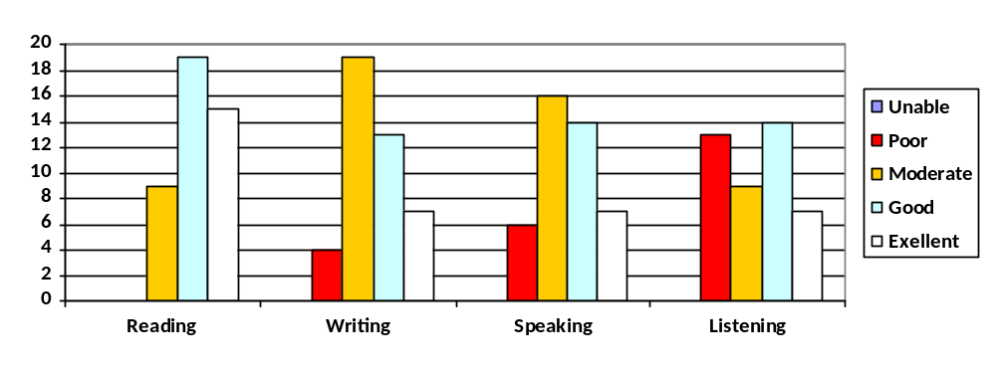
Fig. 1. Students core language skills self-evaluation breakdown
A half of the students was trained and exposed to experiment only after training.
Experiment:
Two types of content …
First stage
Questions of three complexity levels
…
Second stage
Comprehensive exercises:
- Keywords

Training
D. Brazil et all ….
Proclaiming tone | neutral (p-tone): falling tone
Proclaiming tone | dominating (p+ tone): rising-falling tone
Referring tone | neutral (r-tone): falling-rising tone
Referring tone | dominating (r+ tone): rising tone (untypical for scientific discourse)
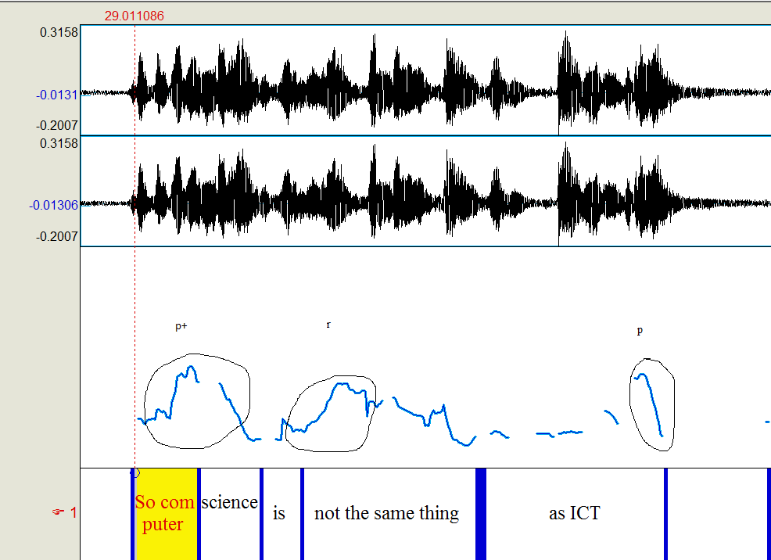
Fig. 2. Phrase sample with p+, r and p-tones
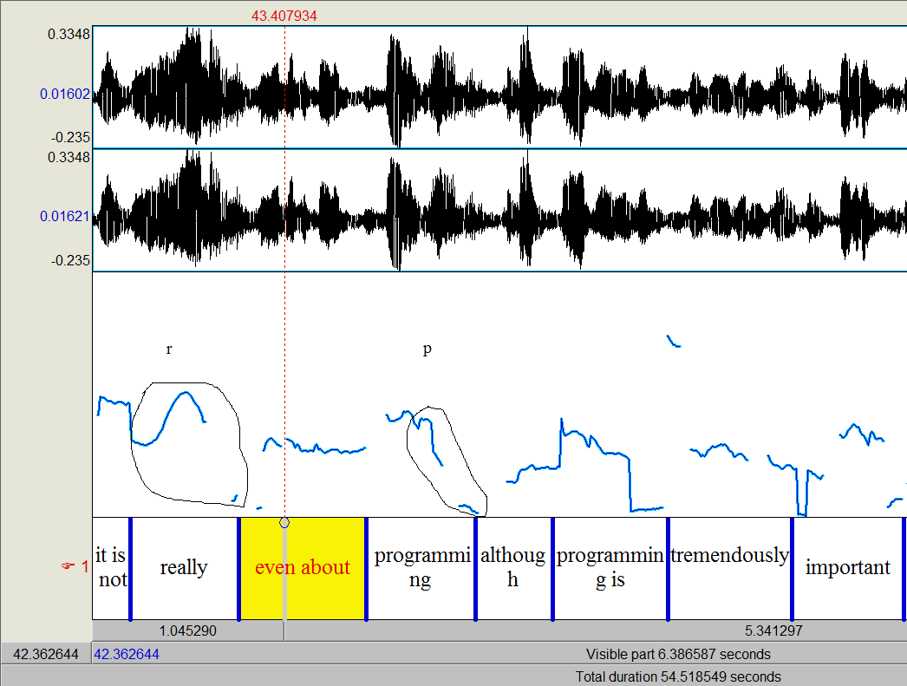
Fig. 3. Phase sample with r and p-tones
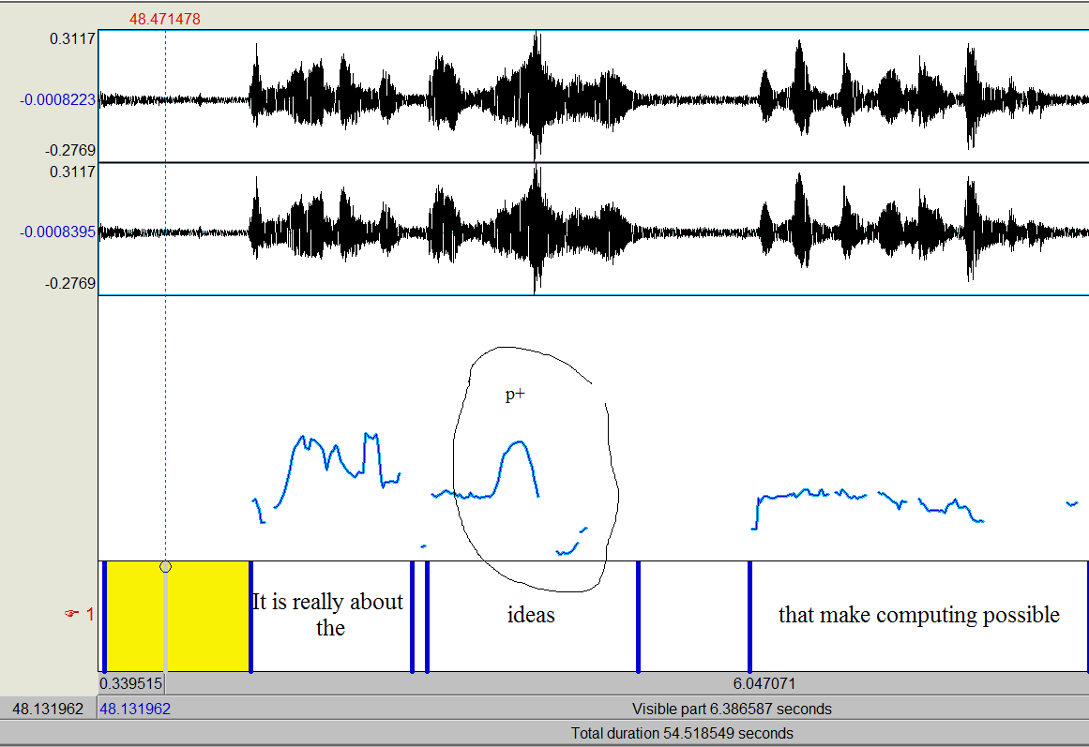
Fig. 4. Phrase sample with p+ nuclear tone – a semantic focus of the whole speech

Results and discussion
The Table 1 shows an average number of correct answers (in %) in each group of questions:
Table 1
Understanding Check (First stage)
Question complexity level | Without training | After Training
* | 77 | 87.5
** | 67 | 79
*** | 34 | 44.5
The Table 2 shows an average successful accomplishment in absolute value or in percentage during the Comprehensive Exercises, the reference numbers are given in the first column in brackets:
Table 2
Comprehensive Exercises (Second stage)
Type of an exercise | Without training | After Training
Marking out the keywords (28 words) | 11 | 17
Content reproduction (text retelling based on keywords) (100%) | 37% | 43%
Intonation marking (9 items) | 2 | 4
Text division into paragraphs (8 paragraphs) | 3 | 7
Understanding check (9 questions) | 4-5 | 5
These results support the fact that listening exercises are difficult for most students.
The research results show some progress in understanding skills after training, although the results still remain moderate when deeper text comprehension is concerned.
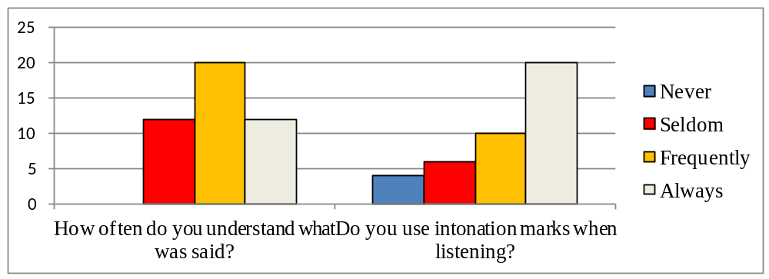
Fig. 5. Audial perception self-evaluation breakdown
Fig.5 shows that students have much intention to analyze the intonation of the speaker and a great impact can be achieved in case they are trained properly.
Conclusions
Reference

